
Green University of Bangladesh
Department of Computer Science and Engineering (CSE)
Faculty of Sciences and Engineering
Semester: (Spring, Year:2026), B.Sc. in CSE (Day)

LAB REPORT NO: 1
Course Title: Operating System Lab
Course Code: CSE 402 Section: 232-D1

Lab Experiment Name: Basic Linux Commands in Ubuntu Terminal

Student Details

Name |  | ID
1. | Rukonuzzaman Topu | 232002280

Submission Date :
Course Teacher’s Name :

[For Teachers use only: Don’t Write Anything inside this box]

Lab Report Status
Marks: ………………………………… Signature:.....................
Comments:.............................................. Date:..............................

1 Objective(s)
To gather knowledge of basic Linux/Unix commands in the Ubuntu terminal: file manipulation, wildcards, permissions, filters, regular expressions, piping and redirection, and process management.

2 Linux Commands
A command line (terminal) is a text based interface to the operating system. Commands are typed into a shell, most commonly Bash (Bourne Again Shell), which executes them and prints the result. This report lists 200 commonly used Linux/Unix commands, grouped by purpose. Each entry has the command name, a description, its syntax, an example and the expected output.

2.1 Terminal and Basic Navigation
These commands help you find out where you are, move around the file system and get basic information about your session.
Command 1: pwd
The pwd command in Linux is used to print the absolute path of the current working directory.
Syntax:
pwd
Example:
Pwd
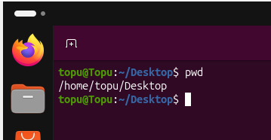
Output: Prints the full path of the directory you are currently in.

Command 2: ls
The ls command in Linux is used to list the files and directories inside a directory.
Syntax:
ls
Example:
ls
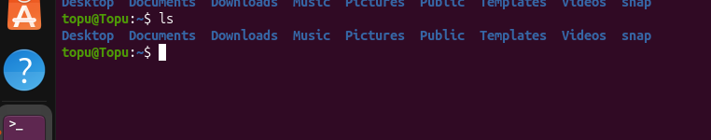
Output: Lists the contents of the Topu directory in long format.

Command 3: cd
The cd command in Linux is used to change the current working directory.
Syntax:
cd [directory]
Example:
cd Desktop
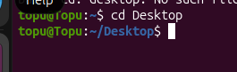
Output: The prompt now shows Documents as the working directory.

Command 4: cd ..
The cd .. command in Linux is used to move one level up to the parent directory.
Syntax:
cd ..
Example:
cd ..
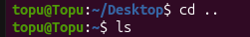
Output: The working directory changes to the parent directory.

Command 5: cd ~
The cd ~ command in Linux is used to jump straight to the home directory.
Syntax:
cd ~
Example:
cd ~
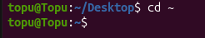
Output: The working directory changes to your home directory.

Command 6: cd -
The cd - command in Linux is used to switch back to the previous working directory.
Syntax:
cd -
Example:
cd –
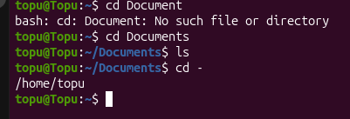cle
Output: Returns to the directory you were in before and prints its path.

Command 7: clear
The clear command in Linux is used to clear the terminal screen.
Syntax:
clear
Example:
Clear
Before
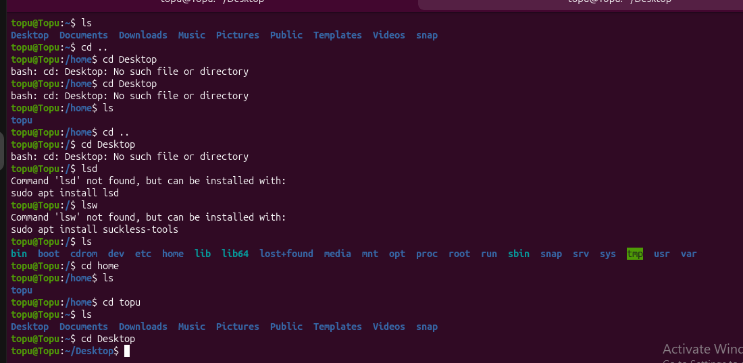
After
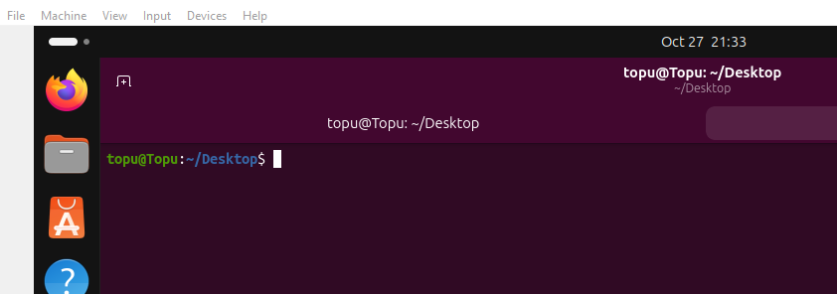
Output: The terminal screen is cleared and the prompt moves to the top.

Command 8: exit
The exit command in Linux is used to close the current shell session or terminal.
Syntax:
exit
Example:
Exit
Before
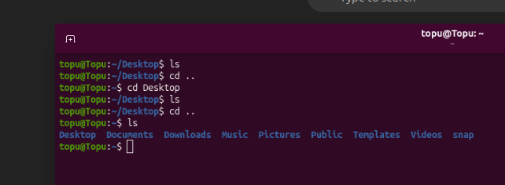

After
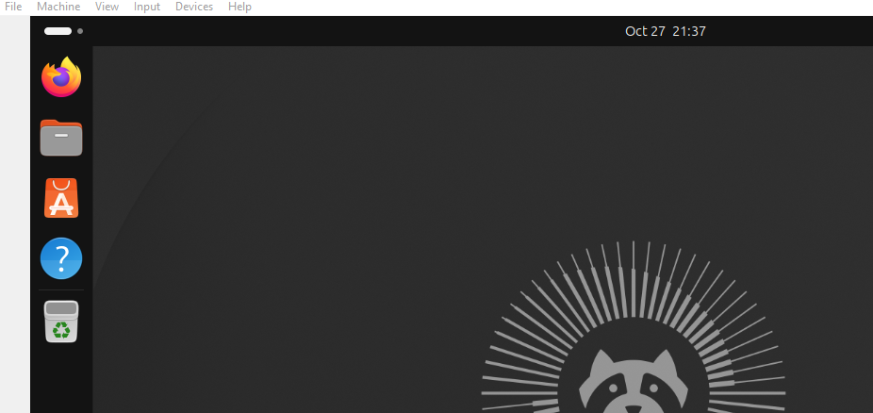Output: The terminal window or shell session is closed.

Command 9: whoami
The whoami command in Linux is used to display the username of the current user.
Syntax:
whoami
Example:
Whoami
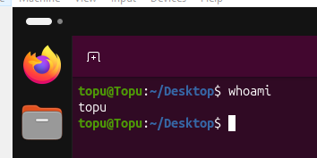
Output: The username of the logged-in user is displayed.

Command 10: hostname
The hostname command in Linux is used to show (or set) the host name of the system.
Syntax:
hostname
Example:
Hostname
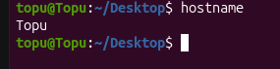
Output: The host name of the computer is displayed.

Command 11: echo
The echo command in Linux is used to print text or the value of a variable on the screen.
Syntax:
echo [string]
Example:
echo $SHELL
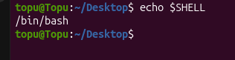
Output: Prints the current shell, for example /bin/bash.

Command 12: date
The date command in Linux is used to display or set the system date and time.
Syntax:
date
Example:
Date
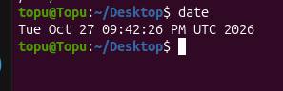
Output: Prints today's date in day-month-year format.

Command 13: cal
The cal command in Linux is used to display a calendar of the current or a given month.
Syntax:
cal [month] [year]
Example:
cal 10 2026
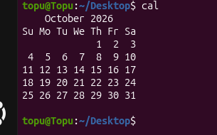
Output: Prints the calendar of October 2026.

Command 14: history
The history command in Linux is used to list the commands previously typed in the shell.
Syntax:
history [n]
Example:
history 10
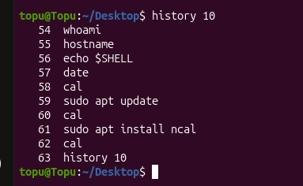
Output: Shows the last 10 commands typed in the shell.

Command 15: man
The man command in Linux is used to open the manual page of a command.
Syntax:
man [command]
Example:
man ls
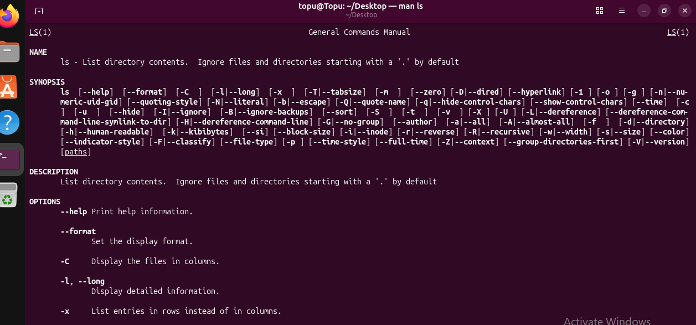
Output: The manual page of the ls command opens; press q to quit.

2.2 File and Directory Manipulation
These commands are used to create, copy, move, rename, link and delete files and directories.
Command 16: touch
The touch command in Linux is used to create an empty file or update the timestamp of an existing file.
Syntax:
touch [file]
Example:
touch topu.txt modu.txt
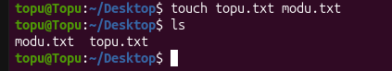
Output: Creates the empty files topu.txt and modu.txt; confirm with ls.

Command 17: mkdir
The mkdir command in Linux is used to create a new directory.
Syntax:
mkdir [directory]
Example:
mkdir Topu
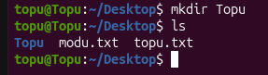
Output: A new directory named Topu is created in the current directory.

Command 18: mkdir -p
The mkdir -p command in Linux is used to create nested directories (and missing parents) in one step.
Syntax:
mkdir -p [path]
Example:
mkdir -p lab/week1/day1
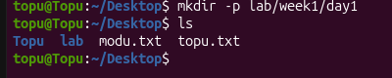
Output: The directories lab, week1 and day1 are created inside each other.

Command 19: rmdir
The rmdir command in Linux is used to remove an empty directory.
Syntax:
rmdir [directory]
Example:
rmdir Green
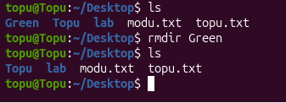
Output: The empty directory Green is removed.

Command 20: cp
The cp command in Linux is used to copy a file from source to destination.
Syntax:
cp [source] [destination]
Example:
cp topu.txt backup.txt
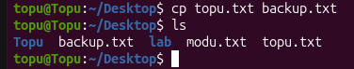
Output: A copy of topu.txt named backup.txt is created.

Command 21: cp -r
The cp -r command in Linux is used to copy a directory and all of its contents recursively.
Syntax:
cp -r [source_dir] [dest_dir]
Example:
cp -r lab Example_bak
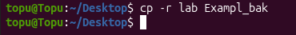
Output: The lab directory and all its files are copied to Example_bak.

Command 22: mv
The mv command in Linux is used to move or rename a file or directory.
Syntax:
mv [source] [destination]
Example:
mv modu.txt butterfly.txt
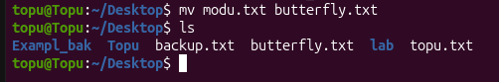
Output: The file modu.txt is renamed to butterfly.txt.

Command 23: rm
The rm command in Linux is used to delete a file.
Syntax:
rm [file]
Example:
rm butterfly.txt
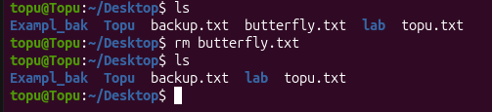
Output: The file butterfly.txt is deleted permanently.

Command 24: rm -r
The rm -r command in Linux is used to delete a directory together with everything inside it.
Syntax:
rm -r [directory]
Example:
rm -r Exampl_bak
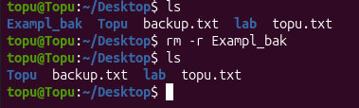
Output: The Exampl_bak directory and everything inside it are deleted.

Command 25: rm -i
The rm -i command in Linux is used to delete files but ask for confirmation before each removal.
Syntax:
rm -i [file]
Example:
rm -i test.sh
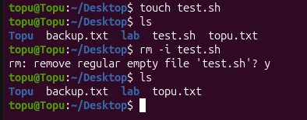
Output: Asks for confirmation before deleting test.sh; type y to confirm.

Command 26: ln
The ln command in Linux is used to create a hard link to a file.
Syntax:
ln [target] [link_name]
Example:
ln file1.txt hardlink1
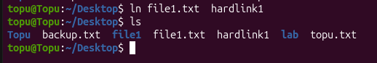
Output: hardlink1 becomes another name for the same data as file1.

Command 27: ln -s
The ln -s command in Linux is used to create a symbolic (soft) link to a file or directory.
Syntax:
ln -s [target] [link_name]
Example:
ln -s ~/Documents docs
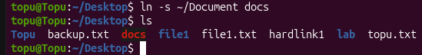
Output: A shortcut named docs that points to the Documents directory is created.

Command 28: stat
The stat command in Linux is used to display the detailed status of a file: size, inode, permissions and timestamps.
Syntax:
stat [file]
Example:
Stat Topu
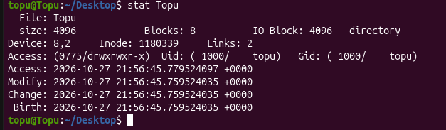
Output: Shows size, permissions, inode, and access/modify times of Topu.

Command 29: file
The file command in Linux is used to identify the type of a file by examining its content.
Syntax:
file [file]
Example:
file flower.png
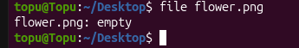
Output: Reports the file type, for example PNG image data.

Command 30: tree
The tree command in Linux is used to display the directory structure as a tree (install with apt if missing).
Syntax:
tree [directory]
Example:
tree lab
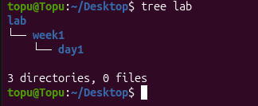
Output: Prints all files and sub-directories of lab as a tree.

Command 31: basename
The basename command in Linux is used to strip the directory part from a path and print only the file name.
Syntax:
basename [path]
Example:
basename /home/user/report.txt
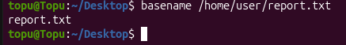
Output: Prints only report.txt, with the directory path removed.

2.3 Viewing File Content
These commands display the content of a file in different ways.
Command 32: catnano
The cat command in Linux is used to display the content of a file or join several files together.
Syntax:
cat [file]
Example:
cat filter.txt
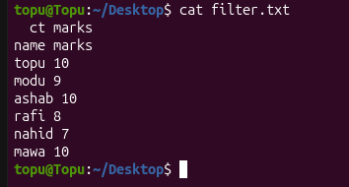
Output: The full content of filter.txt is printed on the screen.

Command 33: tac
The tac command in Linux is used to display the content of a file with the lines in reverse order.
Syntax:
tac [file]A
Example:
tac filter.txt
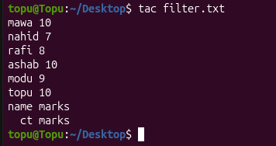
Output: The lines of filter.txt are printed from last to first.

Command 34: more
The more command in Linux is used to show a file one screen at a time (forward scrolling only).
Syntax:
more [file]
Example:
more filter.txt
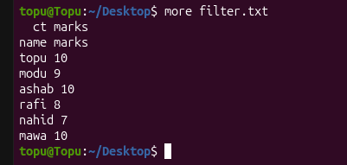
Output: filter.txt is shown one screen at a time; press the space bar for the next page.

Command 35: less
The less command in Linux is used to show a file page by page with both forward and backward scrolling.
Syntax:
less [file]
Example:
less /etc/passwd
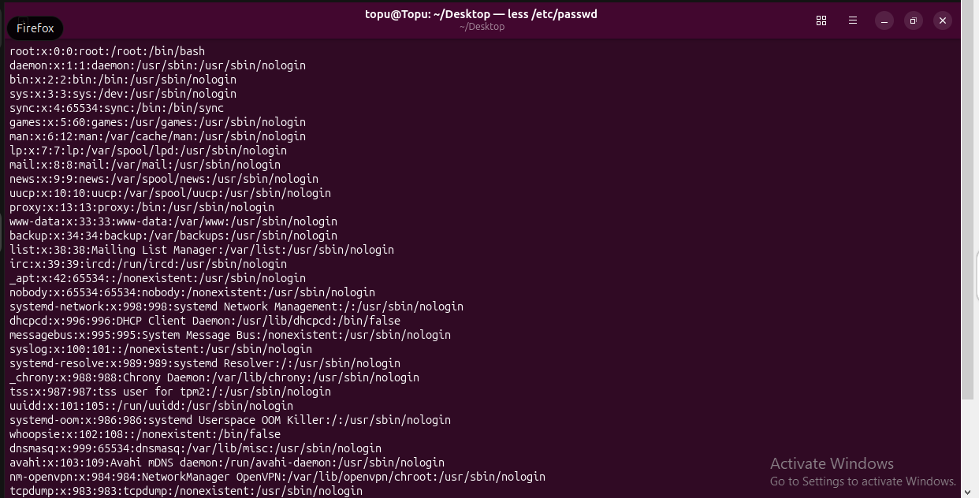
Output: The file opens in a scrollable viewer; press q to quit.

Command 36: head
The head command in Linux is used to print the first lines of a file (10 by default).
Syntax:
head [-n] [file]
Example:
head -3 filter.txt
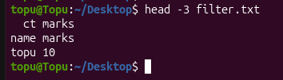
Output: Only the first 3 lines of filter.txt are displayed.

Command 37: tail
The tail command in Linux is used to print the last lines of a file (10 by default).
Syntax:
tail [-n] [file]
Example:
tail -5 filter.txt
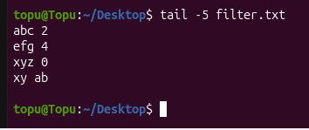
Output: Only the last 5 lines of filter.txt are displayed.

Command 38: tail -f
The tail -f command in Linux is used to follow a file and print new lines as they are appended to it.
Syntax:
tail -f [file]
Example:
tail -f filter.txt /var/log/syslog
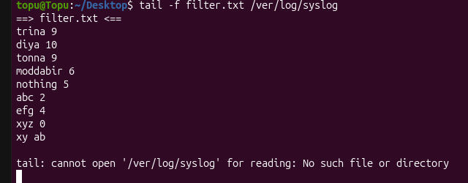
Output: The log is displayed and keeps updating as new lines arrive; press Ctrl+C to stop.

Command 39: nl
The nl command in Linux is used to number the lines of a file.
Syntax:
nl [options] [file]
Example:
nl -s '. ' -w 10 filter.txt
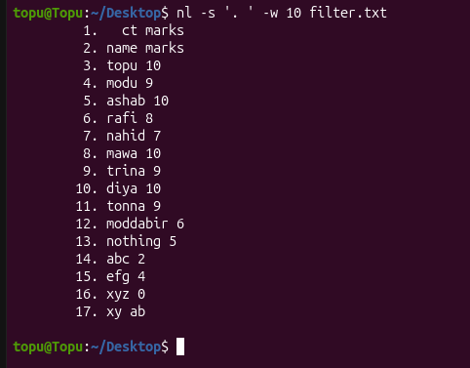
Output: Lines are numbered with ". " after the number and a number width of 10.

Command 40: wc
The wc command in Linux is used to count the lines, words and bytes of a file.
Syntax:
wc [options] [file]
Example:
wc -l filter.txt
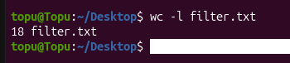
Output: Prints the number of lines in filter.txt.

Command 41: xxd
The xxd command in Linux is used to show a hexadecimal dump of a file.
Syntax:
xxd [file]
Example:
xxd filter.txt
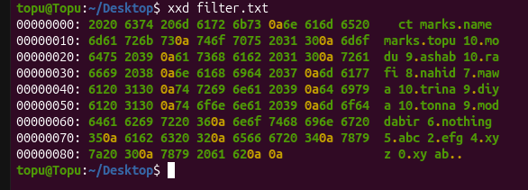
Output: Prints the bytes of filter.txt in hexadecimal next to the text.

2.4 Filters and Text Processing
A filter is a program that accepts textual data and transforms it in a particular way. These commands are often combined using pipes.
Command 42: sort
The sort command in Linux is used to sort the lines of text alphabetically.
Syntax:
sort [options] [file]
Example:
sort filter.txt
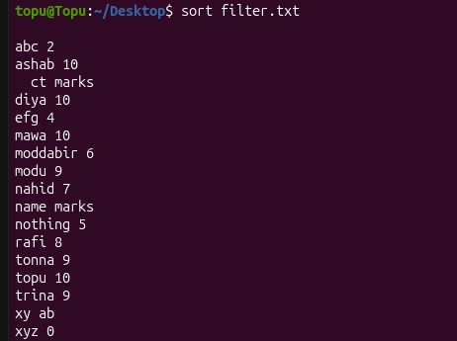
Output: The lines of filter.txt are displayed in alphabetical order.

Command 43: sort -n
The sort -n command in Linux is used to sort the lines numerically instead of alphabetically.
Syntax:
sort -n [file]
Example:
sort -n -k3 filter.txt
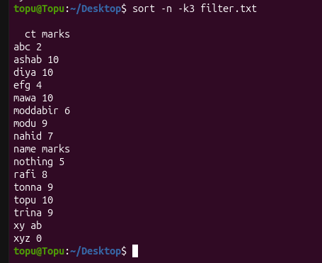
Output: The lines are ordered by the number in the third column.

Command 44: sort -r
The sort -r command in Linux is used to sort the lines in reverse order.
Syntax:
sort -r [file]
Example:
sort -r filter.txt
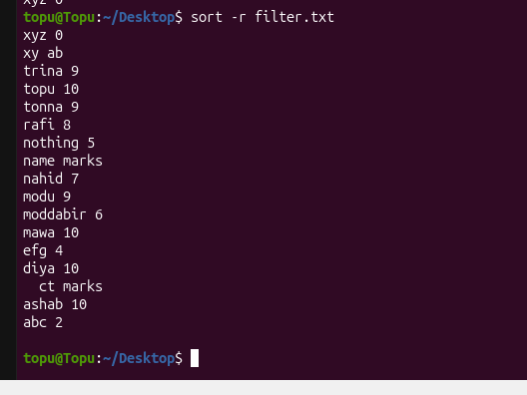
Output: The lines are displayed in reverse alphabetical order.

Command 45: uniq
The uniq command in Linux is used to remove adjacent duplicate lines (input should be sorted first).
Syntax:
uniq [file]
Example:
sort filter.txt | uniq
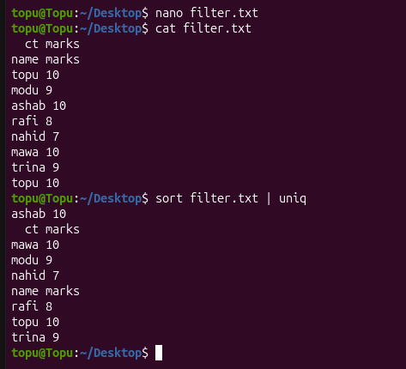
Output: Duplicate lines are removed after sorting.

Command 46: uniq -c
The uniq -c command in Linux is used to count how many times each line occurs.
Syntax:
uniq -c [file]
Example:
sort filter.txt | uniq -c
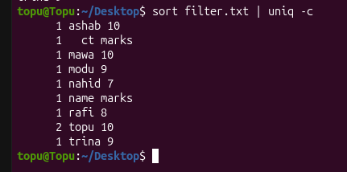
Output: Each unique line is printed with the number of times it occurs.

Command 47: cut
The cut command in Linux is used to extract selected fields (columns) from each line.
Syntax:
cut -d'[delimiter]' -f[fields] [file]
Example:
cut -f 1,2 -d ' ' filter.txt
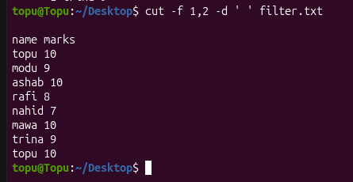
Output: Only the first two columns (name and fruit) of each line are shown.

Command 48: paste
The paste command in Linux is used to merge the lines of files side by side.
Syntax:
paste [file1] [file2]
Example:
paste topu.txt filter.txt
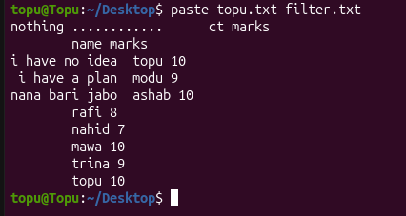
Output: The lines of both files are printed side by side, separated by a tab.

Command 49: join
The join command in Linux is used to join the lines of two sorted files on a common field.
Syntax:
join [file1] [file2]
Example:
join topu.txt filter.txt
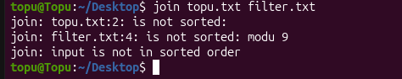
Output: Lines that share the same first field are combined into one line.

Command 50: tr
The tr command in Linux is used to translate or delete characters from the input.
Syntax:
tr [set1] [set2]
Example:
echo "Topu" | tr a-z A-Z
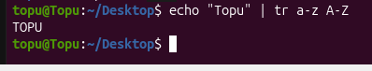
Output: Prints TOPU; all lowercase letters are converted to uppercase.

Command 51: sed
The sed command in Linux is used to search and replace text in a stream or file.
Syntax:
sed 's/search/replace/g' [file]
Example:
sed 's/Mark/Jahid/g' filter.txt
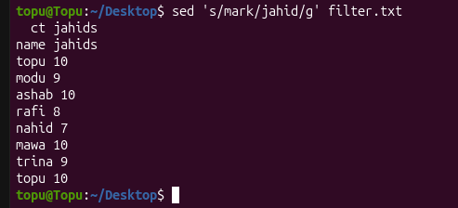
Output: Every Mark in filter.txt is shown as Jahid; the file itself is not changed.

Command 52: awk
The awk command in Linux is used to scan patterns and process text field by field.
Syntax:
awk '{print $n}' [file]
Example:
awk '{print $1, $3}' filter.txt
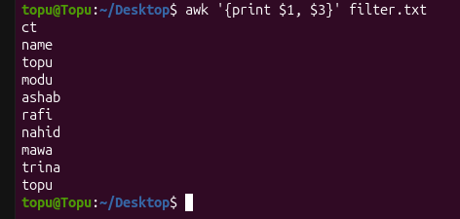
Output: Only the first and third columns (name and number) are printed.

Command 53: tee
The tee command in Linux is used to read input and write it to both the screen and a file.
Syntax:
command | tee [file]
Example:
ls | tee list.txt
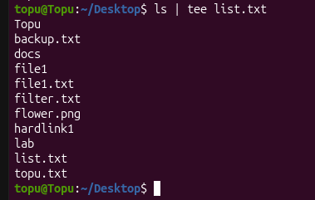
Output: The listing is shown on the screen and also saved in list.txt.

Command 54: diff
The diff command in Linux is used to compare two files line by line and show the differences.
Syntax:
diff [file1] [file2]
Example:
diff topu.txt filter.txt
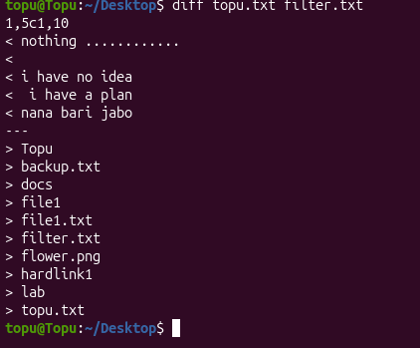
Output: Lines that differ between the two files are displayed.

Command 55: cmp
The cmp command in Linux is used to compare two files byte by byte.
Syntax:
cmp [file1] [file2]
Example:
cmp topu.txt filter.txt
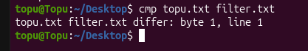
Output: Reports the first byte and line where the files differ (no output if identical).

Command 56: comm
The comm command in Linux is used to compare two sorted files and print unique and common lines in columns.
Syntax:
comm [file1] [file2]
Example:
comm topu.txt filter.txt
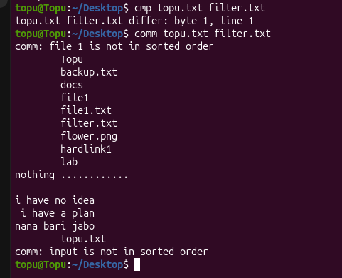
Output: Prints three columns: lines only in file1, only in file2, and common to both.

Command 57: rev
The rev command in Linux is used to reverse the characters of every line.
Syntax:
rev [file]
Example:
rev filter.txt
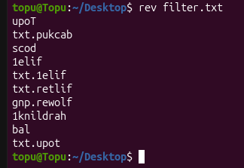
Output: Each line is printed with its characters in reverse order.

2.5 Searching and Regular Expressions
These commands search for text inside files and for files inside directories. Regular expressions describe the patterns to look for.
Command 58: grep
The grep command in Linux is used to search a file and print every line that contains a pattern.
Syntax:
grep [pattern] [file]
Example:
grep "mellons" RE.txt

Output: Lines containing mellons are printed.

Command 59: egrep
The egrep command in Linux is used to search for patterns using extended regular expressions.
Syntax:
egrep [pattern] [file]
Example:
egrep 'or|is|go' RE.txt
Output: Lines containing or, is or go are printed.

Command 60: fgrep
The fgrep command in Linux is used to search for fixed strings only, without regular expressions (same as grep -F).
Syntax:
fgrep [string] [file]
Example:
fgrep "2.+" RE.txt
Output: Lines containing the exact text 2.+ are printed; . and + are not special here.

Command 61: grep -i
The grep -i command in Linux is used to search while ignoring upper and lower case.
Syntax:
grep -i [pattern] [file]
Example:
grep -i “topu" filter.txt
Output: Lines containing susy in any letter case are printed.

Command 62: grep -n
The grep -n command in Linux is used to print matching lines together with their line numbers.
Syntax:
grep -n [pattern] [file]
Example:
grep -n "mellons" RE.txt
Output: Matching lines are printed with their line numbers.

Command 63: grep -c
The grep -c command in Linux is used to print only the number of matching lines.
Syntax:
grep -c [pattern] [file]
Example:
grep -c "mellons" RE.txt
Output: Only the number of matching lines is printed.

Command 64: grep -v
The grep -v command in Linux is used to print the lines that do not match the pattern.
Syntax:
grep -v [pattern] [file]
Example:
grep -v "oranges" filter.txt
Output: All lines that do not contain oranges are printed.

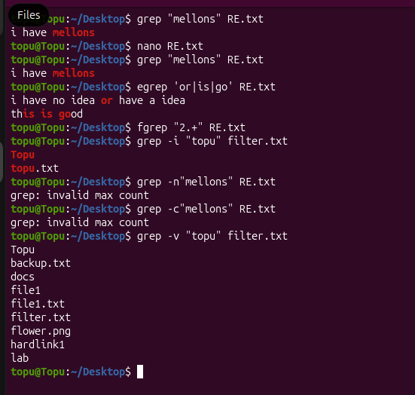

Command 65: grep -r
The grep -r command in Linux is used to search recursively through all files in a directory.
Syntax:
grep -r [pattern] [directory]
Example:
grep -r "main" ~/Documents
Output: Matching lines are printed together with the name of the file that contains them.

Command 66: find
The find command in Linux is used to search for files and directories in a directory hierarchy.
Syntax:
find [path] -name [pattern]
Example:
find ~ -name "*.txt"
Output: The paths of all .txt files under the home directory are listed.

Command 67: locate
The locate command in Linux is used to find files quickly using a prebuilt database.
Syntax:
locate [name]
Example:
locate filter.txt
Output: The full path of every file named filter.txt is printed.

Command 68: which
The which command in Linux is used to show the full path of the executable of a command.
Syntax:
which [command]
Example:
which python3
Output: Prints the path of the python3 executable, for example /usr/bin/python3.

Command 69: whereis
The whereis command in Linux is used to locate the binary, source and manual page of a command.
Syntax:
whereis [command]
Example:
whereis ls
Output: Prints the locations of the ls binary and its manual page.

2.6 Redirection, Piping and Wildcards
Every program has three streams: STDIN (0), STDOUT (1) and STDERR (2). The operators below connect these streams to files and to other programs. Wildcards match several file names at once.
Command 70: >
The > operator in Linux is used to redirect output to a file; the old content of the file is overwritten.
Syntax:
command > [file]
Example:
ls > myoutput
Output: Nothing is printed; the directory listing is saved in the file myoutput.

Command 71: >>
The >> operator in Linux is used to append output to the end of a file.
Syntax:
command >> [file]
Example:
ls >> myoutput
Output: The listing is added to the end of myoutput without erasing it.

Command 72: <
The < operator in Linux is used to take the input of a command from a file.
Syntax:
command < [file]
Example:
sort < filter.txt
Output: sort reads filter.txt as its input and prints the sorted lines.

Command 73: 2>
The 2> operator in Linux is used to redirect error messages (STDERR) to a file.
Syntax:
command 2> [file]
Example:
ls nofile 2> error.log
Output: The error message is saved in error.log instead of being shown on the screen.

Command 74: 2>&1
The 2>&1 operator in Linux is used to send STDERR to the same place as STDOUT.
Syntax:
command > [file] 2>&1
Example:
ls nofile > all.log 2>&1
Output: Both normal output and error messages are saved in all.log.

Command 75: |
The | operator in Linux is used to pass the output of one command as the input of the next command.
Syntax:
command1 | command2
Example:
ls | head -3
Output: Only the first three entries of the listing are displayed.

Command 76: &&
The && operator in Linux is used to run the second command only if the first one succeeds.
Syntax:
command1 && command2
Example:
mkdir test && cd test
Output: cd runs only if mkdir succeeded.

Command 77: ||
The || operator in Linux is used to run the second command only if the first one fails.
Syntax:
command1 || command2
Example:
cd test || echo "not found"
Output: The message is printed only if the cd command fails.

Command 78: ;
The ; operator in Linux is used to run commands one after another, whether or not the previous one succeeds.
Syntax:
command1 ; command2
Example:
pwd ; ls
Output: Both commands run one after the other.

Command 79: xargs
The xargs command in Linux is used to build and run commands using items read from standard input.
Syntax:
command | xargs [command]
Example:
find . -name "*.tmp" | xargs rm
Output: All .tmp files found in the current directory tree are deleted.

Command 80: <<
The << operator in Linux is used to pass several lines of text to a command as input until a delimiter word is reached.
Syntax:
command << [DELIMITER]
Example:
cat << EOF
Output: The lines you type are read as input until you type EOF on a line by itself.

Command 81: *
The * wildcard in Linux is used to match zero or more characters in a file name.
Syntax:
ls [pattern]
Example:
ls b*
Output: Lists every file whose name begins with b.

Command 82: ?
The ? wildcard in Linux is used to match exactly one character in a file name.
Syntax:
ls [pattern]
Example:
ls ?i*
Output: Lists files whose second character is i, such as firstfile.

Command 83: [ ]
The [ ] wildcard in Linux is used to match one character from a set or a range of characters.
Syntax:
ls [pattern]
Example:
ls [a-v]*
Output: Lists files whose names start with a letter from a to v.

2.7 Permissions and Ownership
Linux permissions control what the owner, the group and others may do with a file: read (r), write (w) and execute (x).
Command 84: ls -l
The ls -l command in Linux is used to list files in long format showing permissions, owner, group, size and date.
Syntax:
ls -l [path]
Example:
ls -l frog.png
Output: Shows permissions such as -rwxr-----x along with owner, group, size and date.

Command 85: chmod
The chmod command in Linux is used to change file permissions using symbolic mode (who, +/-, permission).
Syntax:
chmod [ugoa][+-][rwx] [file]
Example:
chmod g+x frog.png
Output: Execute permission is added for the group; check with ls -l.

Command 86: chmod +x
The chmod +x command in Linux is used to make a file executable, for example a shell script.
Syntax:
chmod +x [file]
Example:
chmod +x addition.sh
Output: The script becomes executable and can be run with ./addition.sh.

Command 87: chmod 755
The chmod 755 command in Linux is used to set permissions using numeric (octal) mode.
Syntax:
chmod [mode] [file]
Example:
chmod 755 addition.sh
Output: The owner gets rwx; the group and others get r-x.

Command 88: chmod -R
The chmod -R command in Linux is used to change permissions of a directory and its contents recursively.
Syntax:
chmod -R [mode] [directory]
Example:
chmod -R u+w Documents
Output: The owner gets write permission on Documents and everything inside it.

Command 89: chown
The chown command in Linux is used to change the owner of a file.
Syntax:
sudo chown [user] [file]
Example:
sudo chown root test.sh
Output: The owner of test.sh becomes root; ls -l shows the change.

Command 90: chgrp
The chgrp command in Linux is used to change the group that owns a file.
Syntax:
sudo chgrp [group] [file]
Example:
sudo chgrp users frog.png
Output: The group of frog.png becomes users.

Command 91: umask
The umask command in Linux is used to display or set the default permission mask for new files.
Syntax:
umask [mode]
Example:
umask 022
Output: New files will be created with default permissions 644 (directories 755).

Command 92: sudo
The sudo command in Linux is used to run a command with superuser (administrator) privileges.
Syntax:
sudo [command]
Example:
sudo apt update
Output: Runs the update command as administrator after asking for your password.

Command 93: su
The su command in Linux is used to switch to another user account.
Syntax:
su [username]
Example:
su - root
Output: Asks for the root password and opens a shell as root; type exit to return.

Command 94: id
The id command in Linux is used to display the user ID and group IDs of a user.
Syntax:
id [username]
Example:
id
Output: Prints your user ID, group ID and the groups you belong to.

Command 95: groups
The groups command in Linux is used to show the groups a user belongs to.
Syntax:
groups [username]
Example:
groups
Output: Prints the names of the groups the current user belongs to.

2.8 Process Management
Linux is a multitasking operating system. These commands show what is running, control running programs and manage background jobs.
Command 96: ps
The ps command in Linux is used to show the processes running in the current terminal.
Syntax:
ps
Example:
ps
Output: Shows the PID, terminal, time and name of processes in this terminal.

Command 97: ps aux
The ps aux command in Linux is used to show all running processes of all users in detail.
Syntax:
ps aux
Example:
ps aux | grep 'firefox'
Output: Only the lines of processes related to firefox are displayed.

Command 98: top
The top command in Linux is used to show a real-time view of processes and resource usage.
Syntax:
top
Example:
top
Output: A live, updating table of processes with CPU and memory use; press q to quit.

Command 99: htop
The htop command in Linux is used to view running processes interactively.
Syntax:
htop
Example:
htop
Output: A colourful interactive process viewer opens; press F10 to quit.

Command 100: kill
The kill command in Linux is used to terminate a process using its process ID (PID).
Syntax:
kill [PID]
Example:
kill 6310
Output: The process with PID 6310 is asked to terminate.

Command 101: kill -9
The kill -9 command in Linux is used to forcefully kill a process using the SIGKILL signal.
Syntax:
kill -9 [PID]
Example:
kill -9 6310
Output: The process 6310 is stopped immediately.

Command 102: killall
The killall command in Linux is used to kill all processes with a given name.
Syntax:
killall [name]
Example:
killall firefox
Output: All firefox processes are terminated.

Command 103: pkill
The pkill command in Linux is used to kill processes whose names match a pattern.
Syntax:
pkill [pattern]
Example:
pkill fire
Output: Processes whose names match fire are terminated.

Command 104: pgrep
The pgrep command in Linux is used to find the process IDs of processes by name.
Syntax:
pgrep [name]
Example:
pgrep firefox
Output: Prints the PIDs of firefox processes.

Command 105: pidof
The pidof command in Linux is used to print the PID of a running program.
Syntax:
pidof [program]
Example:
pidof bash
Output: Prints the PID of each running bash shell.

Command 106: jobs
The jobs command in Linux is used to list the background and stopped jobs of the current shell.
Syntax:
jobs
Example:
jobs
Output: Lists background and stopped jobs with their job numbers.

Command 107: bg
The bg command in Linux is used to resume a stopped job in the background.
Syntax:
bg [%job]
Example:
bg %1
Output: Job number 1 continues running in the background.

Command 108: fg
The fg command in Linux is used to bring a background job to the foreground.
Syntax:
fg [%job]
Example:
fg %1
Output: Job number 1 comes to the foreground.

Command 109: nohup
The nohup command in Linux is used to run a command that keeps running after the terminal is closed.
Syntax:
nohup [command] &
Example:
nohup ./addition.sh &
Output: The script keeps running after the terminal is closed; output goes to nohup.out.

Command 110: nice
The nice command in Linux is used to start a process with a chosen scheduling priority.
Syntax:
nice -n [value] [command]
Example:
nice -n 10 ./addition.sh
Output: The script runs with a lower priority (nice value 10).

Command 111: renice
The renice command in Linux is used to change the priority of an already running process.
Syntax:
renice [value] -p [PID]
Example:
renice 5 -p 1234
Output: The priority of process 1234 is changed to 5.

2.9 System Information
These commands report details about the operating system, hardware, memory and the shell environment.
Command 112: uname -a
The uname -a command in Linux is used to print kernel name, version and machine architecture.
Syntax:
uname -a
Example:
uname -a
Output: Prints kernel name, host name, kernel version and architecture.

Command 113: lsb_release -a
The lsb_release -a command in Linux is used to show Ubuntu distribution and release information.
Syntax:
lsb_release -a
Example:
lsb_release -a
Output: Prints the distributor ID, description and release of Ubuntu.

Command 114: lscpu
The lscpu command in Linux is used to display CPU architecture information.
Syntax:
lscpu
Example:
lscpu
Output: Prints CPU model, number of cores, threads and speed.

Command 115: free -h
The free -h command in Linux is used to show used and free memory in human-readable units.
Syntax:
free -h
Example:
free -h
Output: Prints total, used and free RAM and swap in readable units.

Command 116: lshw
The lshw command in Linux is used to list detailed hardware information.
Syntax:
sudo lshw [options]
Example:
sudo lshw -short
Output: Prints a short table of the hardware components.

Command 117: lsusb
The lsusb command in Linux is used to list the USB devices connected to the system.
Syntax:
lsusb
Example:
lsusb
Output: Lists the connected USB devices.

Command 118: lspci
The lspci command in Linux is used to list the PCI devices (graphics, network cards, etc.).
Syntax:
lspci
Example:
lspci
Output: Lists PCI devices such as graphics and network cards.

Command 119: dmesg
The dmesg command in Linux is used to print kernel messages, useful for hardware and boot problems.
Syntax:
dmesg
Example:
dmesg | tail
Output: Prints the last 10 kernel messages.

Command 120: env
The env command in Linux is used to display all environment variables.
Syntax:
env
Example:
env
Output: Prints all environment variables such as HOME and PATH.

Command 121: printenv
The printenv command in Linux is used to print the value of a given environment variable.
Syntax:
printenv [VARIABLE]
Example:
printenv HOME
Output: Prints the value of HOME, for example /home/<username>.

Command 122: export
The export command in Linux is used to set an environment variable for child processes.
Syntax:
export [NAME=value]
Example:
export PATH=$PATH:~/bin
Output: ~/bin is added to PATH for this session and its child processes.

Command 123: alias
The alias command in Linux is used to create a shortcut name for a longer command.
Syntax:
alias [name]='[command]'
Example:
alias ll='ls -l'
Output: Typing ll now runs ls -l (valid for the current terminal session).

2.10 Disk and Storage
These commands report disk usage and manage disks and file systems.
Command 124: df -h
The df -h command in Linux is used to show disk space usage of mounted file systems.
Syntax:
df -h
Example:
df -h
Output: Shows the size, used and free space of each file system.

Command 125: du -sh
The du -sh command in Linux is used to show the total size of a directory.
Syntax:
du -sh [directory]
Example:
du -sh Documents
Output: Prints a single total size for the Documents directory.

Command 126: du -h
The du -h command in Linux is used to show the size of every file and sub-directory.
Syntax:
du -h [directory]
Example:
du -h Documents
Output: Prints the size of every sub-directory and file in Documents.

Command 127: lsblk
The lsblk command in Linux is used to list block devices such as disks and partitions.
Syntax:
lsblk
Example:
lsblk
Output: Prints a tree of disks and partitions.

Command 128: mount
The mount command in Linux is used to attach a file system to a directory.
Syntax:
sudo mount [device] [directory]
Example:
sudo mount /dev/sdb1 /mnt
Output: If the device exists, its files appear in /mnt.

Command 129: umount
The umount command in Linux is used to detach a mounted file system.
Syntax:
sudo umount [directory]
Example:
sudo umount /mnt
Output: The partition is detached from /mnt.

Command 130: fdisk -l
The fdisk -l command in Linux is used to list disk partition tables.
Syntax:
sudo fdisk -l
Example:
sudo fdisk -l
Output: Lists every disk with its partitions and sizes.

Command 131: blkid
The blkid command in Linux is used to show the UUID and file system type of block devices.
Syntax:
sudo blkid
Example:
sudo blkid
Output: Prints the UUID and file system type of each partition.

Command 132: sync
The sync command in Linux is used to flush file system buffers, writing cached data to disk.
Syntax:
sync
Example:
sync
Output: Nothing is printed; cached data is written to disk.

Command 133: fsck
The fsck command in Linux is used to check and repair a file system (run on unmounted disks).
Syntax:
sudo fsck [device]
Example:
sudo fsck /dev/sdb1
Output: The file system is checked and errors are reported (the device must be unmounted).

2.11 Networking
These commands test connectivity, inspect network settings and transfer data between computers.
Command 134: ip addr
The ip addr command in Linux is used to show the IP addresses of all network interfaces.
Syntax:
ip addr show
Example:
ip addr show
Output: Lists the network interfaces with their IP addresses.

Command 135: ifconfig
The ifconfig command in Linux is used to display or configure network interfaces (needs net-tools).
Syntax:
ifconfig
Example:
ifconfig
Output: Shows interface details such as IP address, netmask and packet counts.

Command 136: ping
The ping command in Linux is used to test whether a host is reachable.
Syntax:
ping -c [count] [host]
Example:
ping -c 4 google.com
Output: Sends 4 packets and shows the reply time and packet loss.

Command 137: traceroute
The traceroute command in Linux is used to show the route packets take to reach a host.
Syntax:
traceroute [host]
Example:
traceroute google.com
Output: Lists each router (hop) between your computer and google.com.

Command 138: netstat
The netstat command in Linux is used to display network connections and listening ports.
Syntax:
netstat -tuln
Example:
netstat -tuln
Output: Lists the listening TCP and UDP ports.

Command 139: ss
The ss command in Linux is used to display socket statistics (modern replacement for netstat).
Syntax:
ss -tuln
Example:
ss -tuln
Output: Lists the listening TCP and UDP sockets.

Command 140: curl
The curl command in Linux is used to transfer data from or to a URL.
Syntax:
curl [options] [URL]
Example:
curl -I https://example.com
Output: Prints only the HTTP response headers of the site.

Command 141: wget
The wget command in Linux is used to download files from the web.
Syntax:
wget [URL]
Example:
wget https://example.com/file.zip
Output: The file is downloaded to the current directory with a progress bar.

Command 142: nslookup
The nslookup command in Linux is used to query DNS to find the IP address of a domain.
Syntax:
nslookup [domain]
Example:
nslookup google.com
Output: Prints the DNS server used and the IP address of google.com.

Command 143: dig
The dig command in Linux is used to perform detailed DNS lookups.
Syntax:
dig [domain]
Example:
dig google.com
Output: Prints the full DNS query and answer sections.

Command 144: host
The host command in Linux is used to perform a simple DNS lookup.
Syntax:
host [domain]
Example:
host google.com
Output: Prints the IP addresses of google.com.

Command 145: ssh
The ssh command in Linux is used to log in securely to a remote computer.
Syntax:
ssh [user]@[host]
Example:
ssh student@192.168.1.10
Output: Asks for the password and opens a shell on the remote computer.

Command 146: scp
The scp command in Linux is used to securely copy files between computers.
Syntax:
scp [file] [user]@[host]:[path]
Example:
scp file.txt student@192.168.1.10:/home/student/
Output: The local file is copied to the remote home directory.

Command 147: rsync
The rsync command in Linux is used to efficiently synchronise files and directories.
Syntax:
rsync -av [source] [destination]
Example:
rsync -av Documents/ backup/
Output: Files in Documents are copied to backup with their attributes; later runs copy only changes.

2.12 Package Management
Ubuntu uses the APT package manager (and dpkg) to install and maintain software.
Command 148: apt update
The apt update command in Linux is used to refresh the list of available packages.
Syntax:
sudo apt update
Example:
sudo apt update
Output: The package lists are refreshed from the repositories.

Command 149: apt upgrade
The apt upgrade command in Linux is used to upgrade all installed packages to newer versions.
Syntax:
sudo apt upgrade
Example:
sudo apt upgrade
Output: Installed packages are upgraded after you confirm.

Command 150: apt install
The apt install command in Linux is used to install a package.
Syntax:
sudo apt install [package]
Example:
sudo apt install tree
Output: The tree package is downloaded and installed.

Command 151: apt remove
The apt remove command in Linux is used to remove a package but keep its configuration files.
Syntax:
sudo apt remove [package]
Example:
sudo apt remove tree
Output: The tree program is removed but its settings stay.

Command 152: apt purge
The apt purge command in Linux is used to remove a package together with its configuration files.
Syntax:
sudo apt purge [package]
Example:
sudo apt purge tree
Output: tree and its configuration files are removed.

Command 153: apt autoremove
The apt autoremove command in Linux is used to remove packages that are no longer needed.
Syntax:
sudo apt autoremove
Example:
sudo apt autoremove
Output: Unused dependency packages are removed.

Command 154: apt search
The apt search command in Linux is used to search the package lists for a keyword.
Syntax:
apt search [keyword]
Example:
apt search editor
Output: Lists packages whose name or description contains editor.

Command 155: apt show
The apt show command in Linux is used to show details about a package.
Syntax:
apt show [package]
Example:
apt show vim
Output: Shows the version, size, dependencies and description of vim.

Command 156: dpkg -i
The dpkg -i command in Linux is used to install a local .deb package file.
Syntax:
sudo dpkg -i [file.deb]
Example:
sudo dpkg -i package.deb
Output: The package is installed from the local .deb file.

Command 157: dpkg -l
The dpkg -l command in Linux is used to list all installed packages.
Syntax:
dpkg -l
Example:
dpkg -l | grep vim
Output: Only installed packages that contain vim in their name are listed.

2.13 User and Group Management
These commands create and manage user accounts and groups and show who is logged in.
Command 158: useradd
The useradd command in Linux is used to create a new user account.
Syntax:
sudo useradd -m [username]
Example:
sudo useradd -m student1
Output: A new user student1 with a home directory is created.

Command 159: adduser
The adduser command in Linux is used to create a new user interactively with a home directory.
Syntax:
sudo adduser [username]
Example:
sudo adduser student2
Output: Asks for a password and details, then creates the user.

Command 160: usermod
The usermod command in Linux is used to modify an existing user account.
Syntax:
sudo usermod [options] [username]
Example:
sudo usermod -aG sudo student1
Output: student1 is added to the sudo group.

Command 161: userdel
The userdel command in Linux is used to delete a user account.
Syntax:
sudo userdel -r [username]
Example:
sudo userdel -r student1
Output: The user and their home directory are removed.

Command 162: passwd
The passwd command in Linux is used to change a user's password.
Syntax:
passwd [username]
Example:
passwd
Output: Asks for the current and the new password.

Command 163: groupadd
The groupadd command in Linux is used to create a new group.
Syntax:
sudo groupadd [group]
Example:
sudo groupadd students
Output: A new group called students is created.

Command 164: groupdel
The groupdel command in Linux is used to delete a group.
Syntax:
sudo groupdel [group]
Example:
sudo groupdel students
Output: The group students is removed.

Command 165: who
The who command in Linux is used to show who is currently logged in.
Syntax:
who
Example:
who
Output: Lists logged-in users with their terminal and login time.

Command 166: w
The w command in Linux is used to show who is logged in and what they are doing.
Syntax:
w
Example:
w
Output: Lists logged-in users and what they are doing.

Command 167: last
The last command in Linux is used to show the history of user logins.
Syntax:
last [-n]
Example:
last -n 5
Output: Shows the last 5 login records.

2.14 Archive and Compression
These commands bundle several files into one archive and compress files to save space.
Command 168: tar -cvf
The tar -cvf command in Linux is used to create a tar archive.
Syntax:
tar -cvf [archive.tar] [files]
Example:
tar -cvf backup.tar Documents
Output: Documents is packed into backup.tar and the file names are listed.

Command 169: tar -xvf
The tar -xvf command in Linux is used to extract a tar archive.
Syntax:
tar -xvf [archive.tar]
Example:
tar -xvf backup.tar
Output: Files are extracted from backup.tar into the current directory.

Command 170: tar -czvf
The tar -czvf command in Linux is used to create a gzip-compressed tar archive.
Syntax:
tar -czvf [archive.tar.gz] [files]
Example:
tar -czvf backup.tar.gz Documents
Output: Documents is packed and compressed into backup.tar.gz.

Command 171: tar -xzvf
The tar -xzvf command in Linux is used to extract a .tar.gz archive.
Syntax:
tar -xzvf [archive.tar.gz]
Example:
tar -xzvf backup.tar.gz
Output: backup.tar.gz is decompressed and extracted.

Command 172: gzip
The gzip command in Linux is used to compress a file into a .gz file.
Syntax:
gzip [file]
Example:
gzip filter.txt
Output: filter.txt is replaced by the compressed file filter.txt.gz.

Command 173: gunzip
The gunzip command in Linux is used to decompress a .gz file.
Syntax:
gunzip [file.gz]
Example:
gunzip filter.txt.gz
Output: filter.txt.gz is restored to filter.txt.

Command 174: bzip2
The bzip2 command in Linux is used to compress a file using the bzip2 algorithm.
Syntax:
bzip2 [file]
Example:
bzip2 filter.txt
Output: filter.txt is replaced by filter.txt.bz2.

Command 175: zip
The zip command in Linux is used to create a zip archive.
Syntax:
zip -r [archive.zip] [files]
Example:
zip -r docs.zip Documents
Output: Documents is compressed into docs.zip.

Command 176: unzip
The unzip command in Linux is used to extract a zip archive.
Syntax:
unzip [archive.zip]
Example:
unzip docs.zip
Output: The contents of docs.zip are extracted.

Command 177: xz
The xz command in Linux is used to compress a file using the xz algorithm.
Syntax:
xz [file]
Example:
xz filter.txt
Output: filter.txt is replaced by filter.txt.xz.

2.15 Editors and Shell Scripting
These commands are used to edit text files and to write and run simple Bash scripts such as addition.sh.
Command 178: vi
The vi command in Linux is used to open the Vi editor (press i to insert, Esc then :wq to save and exit).
Syntax:
vi [file]
Example:
vi Firstfile
Output: Opens the file in Vi; press i to type, then Esc and :wq to save and quit.

Command 179: vim
The vim command in Linux is used to open Vim, an improved version of Vi.
Syntax:
vim [file]
Example:
vim addition.sh
Output: Opens the script in Vim.

Command 180: nano
The nano command in Linux is used to open the beginner-friendly Nano editor.
Syntax:
nano [file]
Example:
nano notes.txt
Output: Opens the editor; press Ctrl+O to save and Ctrl+X to exit.

Command 181: gedit
The gedit command in Linux is used to open the GNOME graphical text editor.
Syntax:
gedit [file]
Example:
gedit addition.sh
Output: Opens the script in the graphical gedit window.

Command 182: read
The read command in Linux is used to read a line of input into a shell variable.
Syntax:
read [variable]
Example:
read a
Output: Waits for you to type a value and stores it in the variable a.

Command 183: expr
The expr command in Linux is used to evaluate an arithmetic or string expression.
Syntax:
expr [expression]
Example:
expr 10 + 20
Output: Prints 30.

Command 184: bc
The bc command in Linux is used to perform calculations, including decimals, from the command line.
Syntax:
echo "[expression]" | bc
Example:
echo "scale=2; 10/3" | bc
Output: Prints 3.33.

Command 185: source
The source command in Linux is used to run a script in the current shell.
Syntax:
source [file]
Example:
source ~/.bashrc
Output: Reloads the settings in .bashrc into the current shell.

Command 186: test
The test command in Linux is used to evaluate a condition (file checks, comparisons).
Syntax:
test [condition]
Example:
test -f filter.txt && echo "exists"
Output: Prints exists only when filter.txt is a regular file.

Command 187: bash
The bash command in Linux is used to run a script using the Bash shell.
Syntax:
bash [script]
Example:
bash addition.sh
Output: Runs the script without needing execute permission.

2.16 Miscellaneous Utilities
A few more useful commands that do not fit neatly into the earlier groups.
Command 188: uptime
The uptime command in Linux is used to show how long the system has been running and the load average.
Syntax:
uptime
Example:
uptime
Output: Prints the current time, how long the system has been up, users and load average.

Command 189: pstree
The pstree command in Linux is used to display running processes as a tree.
Syntax:
pstree
Example:
pstree
Output: Shows parent and child processes as a tree.

Command 190: lsof
The lsof command in Linux is used to list open files and the processes that use them.
Syntax:
sudo lsof -i :[port]
Example:
sudo lsof -i :22
Output: Lists the processes that use port 22.

Command 191: watch
The watch command in Linux is used to run a command repeatedly and show its output.
Syntax:
watch -n [seconds] [command]
Example:
watch -n 2 df -h
Output: Runs df -h every 2 seconds; press Ctrl+C to stop.

Command 192: sleep
The sleep command in Linux is used to pause for a given number of seconds.
Syntax:
sleep [seconds]
Example:
sleep 5
Output: The terminal waits 5 seconds before showing the prompt again.

Command 193: time
The time command in Linux is used to measure how long a command takes to run.
Syntax:
time [command]
Example:
time ls
Output: Prints the listing, then the real, user and sys times.

Command 194: seq
The seq command in Linux is used to print a sequence of numbers.
Syntax:
seq [first] [last]
Example:
seq 1 5
Output: Prints the numbers 1 to 5, one per line.

Command 195: printf
The printf command in Linux is used to print formatted text.
Syntax:
printf "[format]" [args]
Example:
printf "%s\n" "Hello"
Output: Prints Hello followed by a new line.

Command 196: unalias
The unalias command in Linux is used to remove an alias.
Syntax:
unalias [name]
Example:
unalias ll
Output: The ll shortcut no longer works.

Command 197: shuf
The shuf command in Linux is used to shuffle the lines of input randomly.
Syntax:
shuf [file]
Example:
shuf filter.txt
Output: The lines of filter.txt are printed in random order.

Command 198: vmstat
The vmstat command in Linux is used to report virtual memory, CPU and I/O statistics.
Syntax:
vmstat [delay] [count]
Example:
vmstat 2 5
Output: Prints memory, CPU and I/O statistics 5 times at 2-second intervals.

Command 199: timedatectl
The timedatectl command in Linux is used to show or change the system time and date settings.
Syntax:
timedatectl
Example:
timedatectl
Output: Prints local time, UTC time and time zone settings.

Command 200: yes
The yes command in Linux is used to repeatedly print a string until it is stopped.
Syntax:
yes [string]
Example:
yes "ok" | head -3
Output: Prints ok three times.

3 Discussion & Conclusion
In this lab I practised 200 Linux/Unix commands covering navigation, file and directory handling, text filters, regular expressions, redirection and piping, permissions and process management. Combining small commands with pipes and redirection showed me how powerful the command line is for processing data and automating work. Based on the focused objective(s) to understand the basic Linux commands, this exercise made me more confident towards the fulfilment of the objective(s).

